Кузнецова О.М.,

учитель английского языка

МОУ Красночикойская СОШ

**Использование метода «проектов» на уроках английского языка**

**на примере выполнения исследовательского проекта в 11-м классе по теме**

**«Права и обязанности подростков» УМК Биболетовой М.З.**

Всем известно, что, в связи с введением стандартов второго поколения, особое внимание в организации учебного проекта уделяется проектной и исследовательской деятельности. Эти формы деятельности обучающихся являются основными в развитии всех видов универсальных учебных действий. Включение учащихся в исследования и проекты ведет за собой не только повышение мотивации к учению, компетенций школьников в различных учебных дисциплинах, но и усиливает социальную значимость обучения.

Учебный проект – творческая работа, связанная с планированием, достижением и описанием определённого результата; «найди потребность и удовлетвори её!» - вот девиз проектной деятельности школьника.

УМК Биболетовой М.З. рассчитан на широкое использование метода проектов в обучении английскому языку, а именно для обобщения изученной темы. Не смотря на существующие методические рекомендации авторов по разработке проектов, от учителя требуется провести большую подготовительную работу, чтобы проект достиг своей основной цели: интеллектуальное, личностное развитие школьников, рост их компетенции в выбранной для иссле­дования или проекта сфере. Чем тщательнее продумает педагог этапы и содержание проектной или исследовательской деятельности, тем успешнее получится результат. Заинтересованность в проекте самого учителя неизменно привлекает и мотивирует учащихся.

В данной статье мы опишем организацию выполнения исследовательского проекта в 11-х классах как результата изучения темы «Права и обязанности подростков». Учащиеся подгруппы делятся на 4 команды и получают задания.

Первая команда изучает понятия «право» и «обязанность», а также знакомятся со статьями Конвенции о правах ребенка (с некоторыми из них они уже знакомы из упражнения учебника). В более сильных группах учащимся предлагаются статьи только на английском языке, в более слабых можно соотнести статьи Конвенции на английском и на русском языках. Дополнительно, можно предложить найти информацию об Организации Объединенных Наций, которая является инициатором Конвенции. После изучения прав, закрепленных в Конвенции о правах ребенка, учащиеся выбирают наиболее важные, на их взгляд, права (не более 10-ти). (Приложение 1)

Вторая команда изучает школьный устав, а именно права и обязанности школьников, определенные уставом образовательного учреждения, выбирают наиболее важные, сравнивают, и делают вывод, чего больше: прав или обязанностей. (Приложение 2)

Третья команда проводит социологическое исследование среди школьников основного и старшего звена. Учащиеся отвечают на следующие вопросы: где закреплены права детей, каким количеством прав они обладают, какие права наиболее значимы. Результаты интервью можно представить описательно в текстовом варианте, а можно составить наглядные диаграммы. (Приложение 3)

Четвертая группа (не более 2-х учащихся) пишут сочинение на английском языке «Право, которое я считаю наиболее важным»

Все четыре группы представляют один общий результат. Это может быть компьютерная презентация, постер, фильм. Как показала практика, в ходе выполнения проекта учащиеся сами дополняют и делают свои задания разнообразнее, выбирают яркие формы представления результатов проекта.

Такими получились проекты 11-х классов МОУ Красночикойская СОШ:

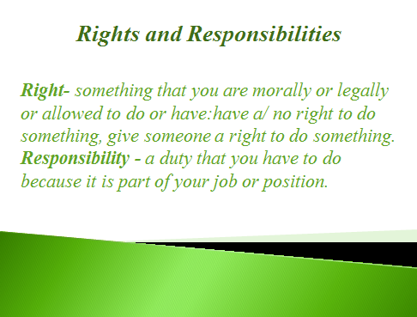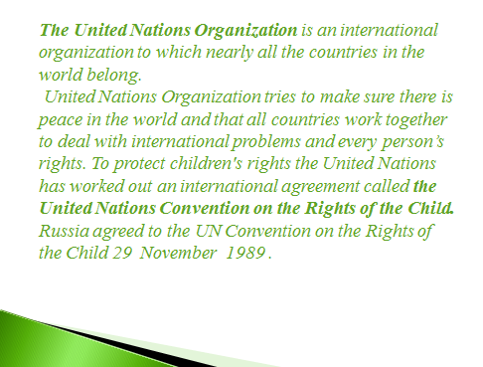

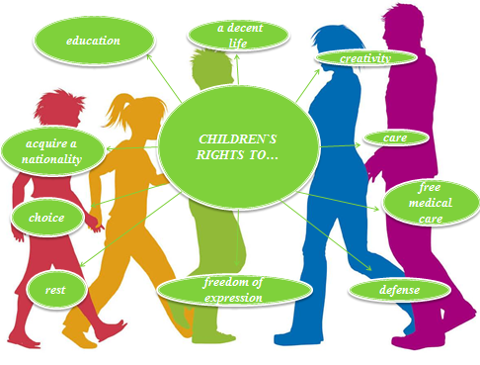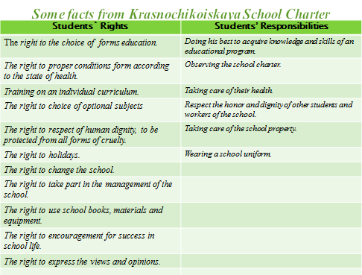

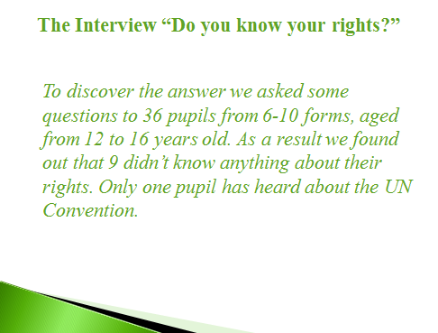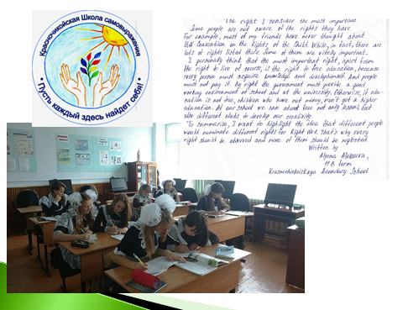

**Приложение 1. Конвенция о правах ребенка**

**Article 2**

1. States Parties shall respect and ensure the rights set forth in the present Convention to each child within their jurisdiction without discrimination of any kind, irrespective of the child's or his or her parent's or legal guardian's race, colour, sex, language, religion, political or other opinion, national, ethnic or social origin, property, disability, birth or other status.

2. States Parties shall take all appropriate measures to ensure that the child is protected against all forms of discrimination or punishment on the basis of the status, activities, expressed opinions, or beliefs of the child's parents, legal guardians, or family members.

**Article 6**  
1. States Parties recognize that every child has the inherent right to life.

2. States Parties shall ensure to the maximum extent possible the survival and development of the child.

**Article 7**

1. The child shall be registered immediately after birth and shall have the right from birth to a name, the right to acquire a nationality and. as far as possible, the right to know and be cared for by his or her parents.

2. States Parties shall ensure the implementation of these rights in accordance with their national law and their obligations under the relevant international instruments in this field, in particular where the child would otherwise be stateless.

**Article 12**

1. States Parties shall assure to the child who is capable of forming his or her own views the right to express those views freely in all matters affecting the child, the views of the child being given due weight in accordance with the age and maturity of the child.

2. For this purpose, the child shall in particular be provided the opportunity to be heard in any judicial and administrative proceedings affecting the child, either directly, or through a representative or an appropriate body, in a manner consistent with the procedural rules of national law.

**Article 15**

1. States Parties recognize the rights of the child to freedom of association and to freedom of peaceful assembly.

2. No restrictions may be placed on the exercise of these rights other than those imposed in conformity with the law and which are necessary in a democratic society in the interests of national security or public safety, public order (ordre public), the protection of public health or morals or the protection of the rights and freedoms of others.

**Article 16**

1. No child shall be subjected to arbitrary or unlawful interference with his or her privacy, family, home or correspondence, nor to unlawful attacks on his or her honour and reputation.

2. The child has the right to the protection of the law against such interference or attacks.

**Article 19**

1. States Parties shall take all appropriate legislative, administrative, social and educational measures to protect the child from all forms of physical or mental violence, injury or abuse, neglect or negligent treatment, maltreatment or exploitation, including sexual abuse, while in the care of parent(s), legal guardian(s) or any other person who has the care of the child.

2. Such protective measures should, as appropriate, include effective procedures for the establishment of social programmes to provide necessary support for the child and for those who have the care of the child, as well as for other forms of prevention and for identification, reporting, referral, investigation, treatment and follow-up of instances of child maltreatment described heretofore, and, as appropriate, for judicial involvement.

**Article 23**

1. States Parties recognize that a mentally or physically disabled child should enjoy a full and decent life, in conditions which ensure dignity, promote self-reliance and facilitate the child's active participation in the community.

2. States Parties recognize the right of the disabled child to special care and shall encourage and ensure the extension, subject to available resources, to the eligible child and those responsible for his or her care, of assistance for which application is made and which is appropriate to the child's condition and to the circumstances of the parents or others caring for the child.

3. Recognizing the special needs of a disabled child, assistance extended in accordance with paragraph 2 of the present article shall be provided free of charge, whenever possible, taking into account the financial resources of the parents or others caring for the child, and shall be designed to ensure that the disabled child has effective access to and receives education, training, health care services, rehabilitation services, preparation for employment and recreation opportunities in a manner conducive to the child's achieving the fullest possible social integration and individual development, including his or her cultural and spiritual development

4. States Parties shall promote, in the spirit of international cooperation, the exchange of appropriate information in the field of preventive health care and of medical, psychological and functional treatment of disabled children, including dissemination of and access to information concerning methods of rehabilitation, education and vocational services, with the aim of enabling States Parties to improve their capabilities and skills and to widen their experience in these areas. In this regard, particular account shall be taken of the needs of developing countries.

**Article 24**

1. States Parties recognize the right of the child to the enjoyment of the highest attainable standard of health and to facilities for the treatment of illness and rehabilitation of health. States Parties shall strive to ensure that no child is deprived of his or her right of access to such health care services.

2. States Parties shall pursue full implementation of this right and, in particular, shall take appropriate measures:

(a) To diminish infant and child mortality;

(b) To ensure the provision of necessary medical assistance and health care to all children with emphasis on the development of primary health care;

(c) To combat disease and malnutrition, including within the framework of primary health care, through, inter alia, the application of readily available technology and through the provision of adequate nutritious foods and clean drinking-water, taking into consideration the dangers and risks of environmental pollution;

(d) To ensure appropriate pre-natal and post-natal health care for mothers;

(e) To ensure that all segments of society, in particular parents and children, are informed, have access to education and are supported in the use of basic knowledge of child health and nutrition, the advantages of breastfeeding, hygiene and environmental sanitation and the prevention of accidents;

(f) To develop preventive health care, guidance for parents and family planning education and services.

3. States Parties shall take all effective and appropriate measures with a view to abolishing traditional practices prejudicial to the health of children.

4. States Parties undertake to promote and encourage international co-operation with a view to achieving progressively the full realization of the right recognized in the present article. In this regard, particular account shall be taken of the needs of developing countries.

**Article 31**

1. States Parties recognize the right of the child to rest and leisure, to engage in play and recreational activities appropriate to the age of the child and to participate freely in cultural life and the arts.

2. States Parties shall respect and promote the right of the child to participate fully in cultural and artistic life and shall encourage the provision of appropriate and equal opportunities for cultural, artistic, recreational and leisure activity.

**Article 32**

1. States Parties recognize the right of the child to be protected from economic exploitation and from performing any work that is likely to be hazardous or to interfere with the child's education, or to be harmful to the child's health or physical, mental, spiritual, moral or social development.

2. States Parties shall take legislative, administrative, social and educational measures to ensure the implementation of the present article. To this end, and having regard to the relevant provisions of other international instruments, States Parties shall in particular:

(a) Provide for a minimum age or minimum ages for admission to employment;

(b) Provide for appropriate regulation of the hours and conditions of employment;

(c) Provide for appropriate penalties or other sanctions to ensure the effective enforcement of the present article.

**Article 37**

States Parties shall ensure that:

(a) No child shall be subjected to torture or other cruel, inhuman or degrading treatment or punishment. Neither capital punishment nor life imprisonment without possibility of release shall be imposed for offences committed by persons below eighteen years of age;

(b) No child shall be deprived of his or her liberty unlawfully or arbitrarily. The arrest, detention or imprisonment of a child shall be in conformity with the law and shall be used only as a measure of last resort and for the shortest appropriate period of time;

(c) Every child deprived of liberty shall be treated with humanity and respect for the inherent dignity of the human person, and in a manner which takes into account the needs of persons of his or her age. In particular, every child deprived of liberty shall be separated from adults unless it is considered in the child's best interest not to do so and shall have the right to maintain contact with his or her family through correspondence and visits, save in exceptional circumstances;

(d) Every child deprived of his or her liberty shall have the right to prompt access to legal and other appropriate assistance, as well as the right to challenge the legality of the deprivation of his or her liberty before a court or other competent, independent and impartial authority, and to a prompt decision on any such action.

**Приложение 2. Устав МОУ … СОШ (пример)**

……..

**Приложение 3. Социологический опрос «Ты знаешь о своих правах?**

**Questions for the interview:**

1. How old are you?
2. What form do you study?
3. Do you know about your rights?
4. Where are children’s rights stated?
5. Have you heard about the UN Convention?
6. How many rights do you have?
7. Name the most important children’s right?

**The Interview “Do you know your rights?”** (Fill in the brackets with your data)

To discover the answer we asked some questions to (number) pupils from (5-11) forms, aged from (number) to (number) years old.

As a result we found out that (number) out of (number) teenagers didn’t know anything about their rights. (Number) children haven’t heard about the UN Convention.

Those who know something about children’s rights think that we have from (number) up to (number) rights. Among them they name the right to (name of the right), right to (name of the right).

**Examples of charts:**